cadoz ®  Bisoprolol Fumrate.... 5mg) |  | Pharmaceutical Manufactures India
 | 
cadoz ®
Each Tablet contains:
Cadoz Tablet
Bisoprolol Fumrate............................ 5mg
INDICATIONS:
Essential HTN, CHD (angina pectoris); as an adjunct in stable chronic heart failure.
DOSAGE AND ADMINISTRATION :-
Essential HTN, CHD 5 mg once daily. If effect is inadequate, 10 mg once daily. Stable chronic heart failure Gradually increase from 1.25 mg/day for 1 wk then 2.5 mg/day for 1 wk then 3.75 mg/day for 1 wk then 5 mg/day for the following 4 wk & 7.5 mg/day for the following 4 wk. Maintenance: 10 mg/day. All doses to be taken once daily.
May be taken with or without food (Swallow whole, do not chew/ crush.)
CONTRAINDICATIONS :-
Untreated myocardial failure, cardiogenic shock, AV block grades II & III, sick-sinus syndrome, SA block, bradycardia w/ <50 beats/min; bronchial asthma, hypotension, advanced stages of peripheral circulatory disturbance; pheochromocytoma w/o concomitant α-adrenoceptor blocker therapy. Pregnancy, lactation; childn.
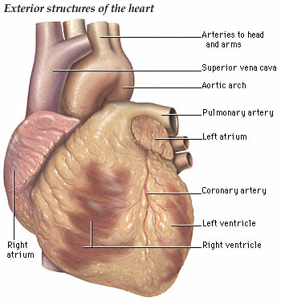

SPECIAL PRECAUTIONS :-
DIabetic patients w/ greatly fluctuating blood-sugar values, during prolonged periods of fasting; acidosis. Prior operation as cardiac output may be impaired under anaesth. Elderly >80 yr.
ADVERSE DRUG REACTIONS :-
At start of treatment but generally recede w/in 1-2 wk treatment: Rare: GI disturbances, skin reactions, decreased BP, slow pulse rate, AV conduction disturbance, cold extremities, muscle weakness/cramp & reduced lacrimation. May aggravate intermittent claudication & Raynaud's phenomenon, intensify myocardial failure, increase airway resistance, impair glucose tolerance, mask signs of low sugar levels. Fatigue, dizziness, slight headache, perspiration, sleep disturbances, vivid dreams & depressive moods.
DRUG INTERACTIONS:-
Reserpine, α methyldopa, clonidine, guanfacine, nifedipine, rifampicin, Ca antagonist of the verapamil & diltiazem type, antiarrhythmics, insulin or oral blood sugar-reducing drugs.
PACKAGING INFORMATION :-
Cadoz Tablet .......................... 5mg
Presentations: 100ml



