FenaCor ®  Fenacor..160mg |  | Pharmaceutical Manufactures India
Taj Products
 | 

FenaCor ®
Uses and Important Safety Information You Should Know About FenaCor

Uses
- FenaCor® (fenofibrate tablets) is a prescription medicine used along with diet to lower triglycerides, total cholesterol, and LDL (bad) cholesterol, and increase HDL (good) cholesterol.
- FenaCor is also used along with diet to lower high triglycerides. Excess body weight, drinking alcohol, diseases such as diabetes and certain thyroid problems, and various drugs can increase triglyceride levels and should be evaluated by your doctor before you take FenaCor.
- FenaCor should be used with a diet low in saturated fat and cholesterol when non-drug measures alone have not been successful.

Important Safety Information
- FenaCor should not be taken by people with liver, gallbladder, or severe kidney disease, or those allergic to any product ingredient.
- FenaCor is associated with increases in liver enzymes as measured by blood tests. Your healthcare provider may do blood tests before and during treatment with FenaCor to check for liver problems.
- Some people who take FenaCor have developed gallstones. Contact your healthcare provider if you experience abdominal pain, nausea, or vomiting while taking FenaCor. These may be signs of inflammation of the gallbladder or pancreas.
- Unexplained muscle pain, tenderness, or weakness, particularly when occurring with tiredness and fever, may be a sign of a serious but rare muscle problem and should be reported to your healthcare provider right away.
- Tell your healthcare provider about all the medicines you take, including any other cholesterol medications, to determine if the combination of these medicines is right for you.
- FenaCor has not been shown to prevent heart disease or heart attack.
- FenaCor may cause allergic-type reactions and possible changes in blood chemistry.
- The most common side effects with FenaCor include stomach pain, back pain, headache, increases in liver enzymes measured by blood tests, and respiratory symptoms.
This is the most important information to know about FenaCor. For more information, talk with your healthcare provider.
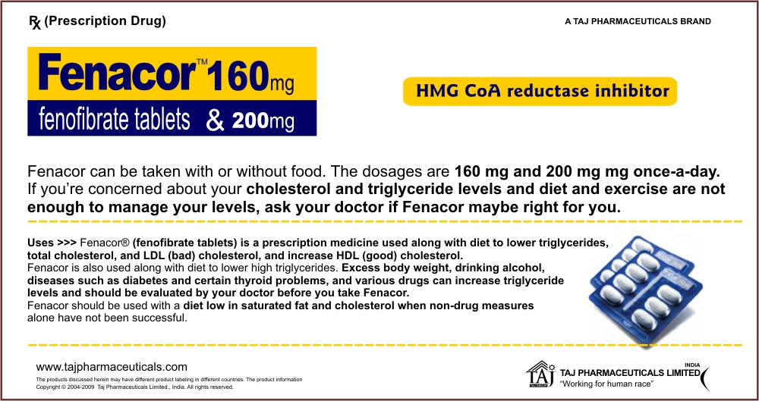

Indications and Important Safety Information About FenaCor

FenaCor Type IIa/IIb Indications
- FenaCor is indicated as adjunctive therapy to diet in adult patients with primary hypercholesterolemia or mixed dyslipidemia (Fredrickson types IIa and IIb) to: increase high-density lipoprotein cholesterol (HDL-C), reduce triglycerides (TG), reduce low-density lipoprotein cholesterol (LDL-C), reduce total cholesterol (Total-C), reduce apolipoprotein B (Apo B).
- Lipid-altering agents should be used in addition to a diet restricted in saturated fat and cholesterol when response to diet and nonpharmacological interventions alone has been inadequate.

FenaCor Type IV/V Indications
- FenaCor is indicated as adjunctive therapy to diet for treatment of adult patients with hypertriglyceridemia (Fredrickson types IV and V hyperlipidemia). Improving glycemic control in diabetic patients with fasting chylomicronemia usually obviates the need for drug therapy.
- The effect of FenaCor on pancreatitis risk reduction in patients with markedly elevated serum TG has not been adequately studied.
- Drug therapy is not indicated for patients with type I hyperlipoproteinemia.
- The use of FenaCor should be considered only when reasonable attempts have been made to obtain satisfactory results with nondrug methods such as diet, exercise, and reduction of alcohol intake. If the decision is made to use FenaCor, the patient should be instructed that this does not reduce the importance of adhering to diet. Diseases or drugs which contribute to hyperlipidemia should be evaluated and appropriate interventions begun.

Important Safety Information
- FenaCor is contraindicated in patients with: hypersensitivity to fenofibrate; hepatic or severe renal dysfunction including primary biliary cirrhosis; unexplained persistent liver function abnormality; and preexisting gallbladder disease.
- Fenofibrate has been associated with increases in serum transaminases. Regular liver function monitoring should be performed, and therapy discontinued if enzyme levels persist >3 times the normal limit.
- Fenofibrate may lead to cholelithiasis. If cholelithiasis is confirmed, FenaCor should be discontinued.
- FenaCor may increase the effects of coumarin-type anticoagulants. Dosage adjustment based on frequent prothrombin time/INR determinations is advisable.
- The combined use of FenaCor and HMG-CoA reductase inhibitors should be avoided unless the benefit of further alterations in lipid levels is likely to outweigh the increased risk. This combination has been associated with rhabdomyolysis, markedly elevated creatine kinase levels and myoglobinuria, leading to acute renal failure.
- FenaCor may occasionally be associated with myositis, myopathy, or rhabdomyolysis. Muscle pain, tenderness, or weakness should have prompt medical evaluation. Discontinue FenaCor if markedly elevated CPK levels occur or myopathy/myositis is suspected or diagnosed.
- The effect of FenaCor on coronary heart disease morbidity and mortality and noncardiovascular mortality has not been established.
- Other precautions include increases in serum creatinine that tend to be reversible, pancreatitis, hypersensitivity reactions, venothromboembolic events, and hematologic changes.
- Adverse events most frequently observed in clinical trials: abnormal liver function tests; respiratory disorder; abdominal pain; back pain; and headache.
Presentation
Fenacor-160 Strips of 10 Tablets
Fenacor-200 Strips of 10 Tablets



