Libtrax ®  chlordiazepoxide hydrochloride  2.5 mg |  | Pharmaceutical Manufactures India
Taj Products
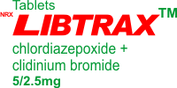 | 
Libtrax ®
Each Libtrax capsule contains
5 mg chlordiazepoxide hydrochloride
2.5 mg clidinium bromide
Each capsule also contains corn starch, lactose and talc. Gelatin capsule shells may contain methyl and propyl parabens and potassium sorbate.
Chlordiazepoxide hydrochloride is a versatile, therapeutic agent of proven value for the relief of anxiety and tension. It is indicated when anxiety, tension or apprehension are significant components of the clinical profile. It is among the safer of the effective psychopharmacologic compounds.
USES
This medication is used along with medications that treat stomach ulcers. This combination product contains 2 medicines, chlordiazepoxide and clidinium. Chlordiazepoxide belongs to a class of drugs known as benzodiazepine anxiolytics. It works by relieving anxiety. Clidinium belongs to a class of drugs known as anticholinergics. It may help symptoms of cramping and abdominal/stomach pain by decreasing stomach acid, and slowing the intestines.
DOSAGE AND ADMINISTRATION
Because of the varied individual responses to tranquilizers and anticholinergics, the optimum dosage of Libtrax varies with the diagnosis and response of the individual patient. The dosage, therefore, should be individualized for maximum beneficial effects. The usual maintenance dose is 1 or 2 capsules, 3 or 4 times a day administered before meals and at bedtime.
Geriatric Dosing
Dosage should be limited to the smallest effective amount to preclude the development of ataxia, oversedation or confusion. The initial dose should not exceed 2 Libtrax capsules per day, to be increased gradually as needed and tolerated.
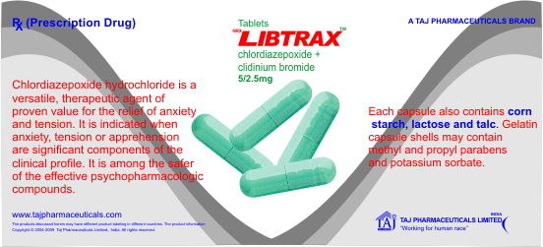
WARNINGS
As in the case of other preparations containing CNS-acting drugs, patients receiving Libtrax should be cautioned about possible combined effects with alcohol and other CNS depressants. For the same reason, they should be cautioned against hazardous occupations requiring complete mental alertness such as operating machinery or driving a motor vehicle.
CONTRAINDICATIONS
Libtrax is contraindicated in the presence of glaucoma (since the anticholinergic component may produce some degree of mydriasis) and in patients with prostatic hypertrophy and benign bladder neck obstruction. It is contraindicated in patients with known hypersensitivity to chlordiazepoxide hydrochloride and/or clidinium bromide.
PATIENT INFORMATION
To assure the safe and effective use of benzodiazepines, patients should be informed that, since benzodiazepines may produce psychological and physical dependence, it is advisable that they consult with their physician before either increasing the dose or abruptly discontinuing this drug.
SIDE EFFECTS
Drowsiness, blurred vision, dry mouth, dry eyes, constipation, or increased heartbeat may occur. If any of these effects persist or worsen, tell your doctor or pharmacist promptly.
To relieve dry mouth, suck on hard candy or ice chips, chew gum, drink water, or use a saliva substitute.
To prevent constipation, maintain a diet adequate in fiber, and drink plenty of water. If you become constipated while using this drug, consult your pharmacist for help in selecting a laxative (e.g., stimulant-type with stool softener).
Presentation
Libtrax Strip pack of 10 Capsules


