metherlin ®  Intramuscularly ..0.2 mg, |  | Pharmaceutical Manufactures India
Taj Products
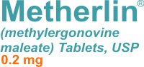 | 
metherlin ®
DRUG DESCRIPTION
Metherlin (methylergonovine maleate) is a semi-synthetic ergot alkaloid used for the prevention and control of postpartum hemorrhage.
Active Ingredient: methylergonovine maleate, USP, 0.2 mg.
Inactive Ingredients: acacia, carnauba wax, D&C Red #7, FD&C Blue #1, gelatin special, lactose, maleic acid, mixed parabens, povidone, sodium benzoate, sodium hydroxide, starch, stearic acid, sucrose, talc, and titanium dioxide.
INDICATIONS
For routine management after delivery of the placenta; postpartum atony and hemorrhage; subinvolution. Under full obstetric supervision, it may be given in the second stage of labor following delivery of the anterior shoulder.
USES
This medication is used to help stop bleeding after delivery of the placenta in childbirth. Methylergonovine maleate belongs to a class of drugs known as ergot alkaloids. It works by increasing the stiffness of the uterus muscles after the last stage of labor. This effect decreases bleeding.
DOSAGE AND ADMINISTRATION
Intramuscularly
0.2 mg, after delivery of the anterior shoulder, after delivery of the placenta, or during the puerperium. May be repeated as required, at intervals of 2-4 hours.
Intravenously
Dosage same as intramuscular.
Orally
One tablet, 0.2 mg, 3 or 4 times daily in the puerperium for a maximum of 1 week.
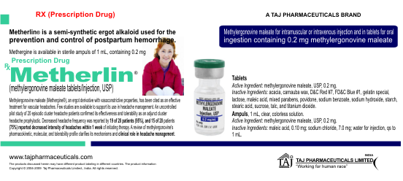
SIDE EFFECTS
The most common adverse reaction is hypertension associated in several cases with seizure and/or headache. Hypotension has also been reported. Nausea and vomiting have occurred occasionally. Rarely observed reactions have included: acute myocardial infarction, transient chest pains, arterial spasm (coronary and peripheral), bradycardia, tachycardia, dyspnea, hematuria, thrombophlebitis, water intoxication, hallucinations, leg cramps, dizziness, tinnitus, nasal congestion, diarrhea, diaphoresis, palpitation, rash, and foul taste.1
There have been rare isolated reports of anaphylaxis, without a proven causal relationship to the drug product.
Drug Abuse And Dependence
Metherlin (methylergonovine maleate) has not been associated with drug abuse or dependence of either a physical or psychological nature.
WARNINGS
This drug should not be administered I.V. routinely because of the possibility of inducing sudden hypertensive and cerebrovascular accidents. If I.V. administration is considered essential as a lifesaving measure, Metherlin (methylergonovine maleate) should be given slowly over a period of no less than 60 seconds with careful monitoring of blood pressure. Intra-arterial or periarterial injection should be strictly avoided.
PRECAUTIONS
Before taking methylergonovine maleate, tell your doctor or pharmacist if you are allergic to it; or to similar ergot alkaloids (e.g., ergonovine); or if you have any other allergies.
This medication should not be used if you have certain medical conditions. Before using this medicine, consult your doctor or pharmacist if you have: high blood pressure, a certain complication of pregnancy (toxemia).
Before using this medication, tell your doctor or pharmacist your medical history, especially of: heart disease (e.g., venoatrial shunt, mitral valve stenosis), other complications during pregnancy (e.g., pre-eclampsia, eclampsia), a serious blood infection (sepsis), blood vessel problems (e.g., Raynaud's phenomenon, obliterative vascular disease), kidney problems, liver problems.
This drug may make you dizzy or drowsy. Use caution while driving, using machinery, or doing any activity that requires alertness. Limit or avoid alcoholic beverages.
STORAGE
Store at room temperature below 77 degrees F (25 degrees C) away from light and moisture. Do not store in the bathroom. Keep all medicines away from children

