Prilosid ®  Gastric ulcer: 20 mg |  | Pharmaceutical Manufactures India
Taj Products
Priloosid ® | 
Prilosid ®
It is a gastric proton pump inhibitor. Omeprazole is a substituted benzimidazole derivative acting on the final step of acid production & therefore controls intragastric acidity irrespective of stimulus. It markedly inhibits basal and stimulated gastric acid secretion. Thus it is antisecretory drug which is very effective for rapidly healing peptic ulcers & erosive oesophagitis & for reducing gastric acid hyper-secretion in patients with Zollinger-Ellison syndrome.
Working
The drug acts by relaxing blood vessels so that blood passes through them more easily. This further helps to lower blood pressure.
Dosage
Gastric ulcer: 20 mg once daily for 8 weeks in sever cases increase to 0 40 mg once daily
Duodenal ulcer: 20 mg once daily for 4 weeks.
Zollinger Ellison Syndrome: 60 mg once daily.
Maintenance therapy: 20 0120 mg adjusted to response.
Contra- Indications: Hypersensitivity, neonates
Side Effects
The drug has certain side effects, that can affect individuals in different ways. The following are some of the side effects, that are often associated with the drug:
* Skin rash
* Nausea
* Headache
* Constipation
* Flatulence
INDICATIONS
Duodenal Ulcer (adults)
Prilosid is indicated for short-term treatment of active duodenal ulcer in adults. Most patients heal within four weeks. Some patients may require an additional four weeks of therapy.
Gastric Ulcer (adults)
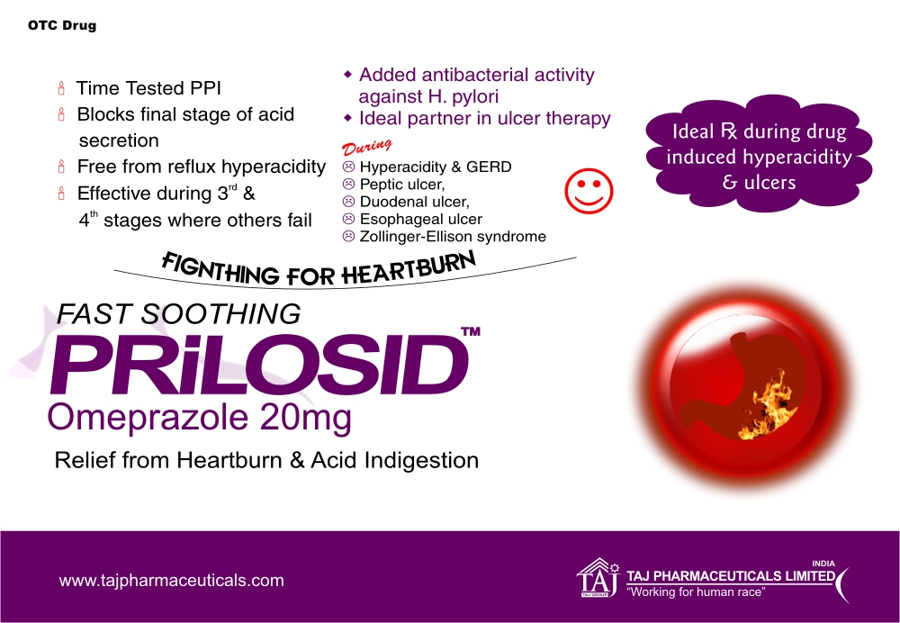
Prilosid is indicated for short-term treatment (4-8 weeks) of active benign gastric ulcer in adults.
PRECAUTIONS
Concomitant Gastric Malignancy
Symptomatic response to therapy with omeprazole does not preclude the presence of gastric malignancy.
Atrophic Gastritis
Atrophic gastritis has been noted occasionally in gastric corpus biopsies from patients treated long-term with omeprazole.

CONTRAINDICATIONS
Omeprazole
Prilosid Delayed-Release Capsules are contraindicated in patients with known hypersensitivity to any component of the formulation.
Clarithromycin
Clarithromycin is contraindicated in patients with a known hypersensitivity to any macrolide antibiotic.
Concomitant administration of clarithromycin with cisapride, pimozide, or terfenadine is contraindicated. There have been post-marketing reports of drug interactions when clarithromycin and/or erythromycin are co-administered with cisapride, pimozide, or terfenadine resulting in cardiac arrhythmias (QT prolongation, ventricular tachycardia, ventricular fibrillation, and torsades de pointes) most likely due to inhibition of hepatic metabolism of these drugs by erythromycin and clarithromycin. Fatalities have been reported. (Please refer to full prescribing information for clarithromycin before prescribing.)
Presentation
Prilosid Capsules Strip of 10 Capsul



