Wallburate ®  Albendazole..400 mg |  | Pharmaceutical Manufactures India
Taj Products
Wallbrurate | 
Wallburate ®
It is a broad spectrum anticonvulsant
Mechanism of Action
Valproate appears to act by multiple mechanisms:
(a) A Phenytoin like frequency dependent prolongation of Na+ channel inactivation
(b) Attenuation of Ca2+ mediated ‘T’ current
(c) Augmentation of release of inhibitory transmitter GABA by inhibiting its degradation as well as increasing its synthesis.
Oral absorption of Valproic acid is good. Peak plasma levels are achieved in 1-4 hrs. It is 90% bound to plasma proteins; 95% metabolized in liver by oxidation and glucuronide conjugation – excreted in urine. Plasma t½ is 15 hours; but anticonvulsant effects are longer lasting
Indications
Valproic acid is highly effective in absence seizures and is an alternative / adjuvant drug for generalized and partial seizures
To prevent recurrent febrile seizures in children, also used in some cases of Myoclonic and Atonic seizures
Dosage
Adults : 200mg 3 times a day, gradually increased at weekly intervals upto a maximum of 600mg 3 times a day according to response.
Children : 10-15mg/kg/day in three divided doses, increase according to response at weekly interval by 5mg/kg/day upto 30-40mg/kg/day
Contraindications
Known hypersensitivity
Special Precautions
Caution in patients in hepatic and renal diseases
Monitor liver function test
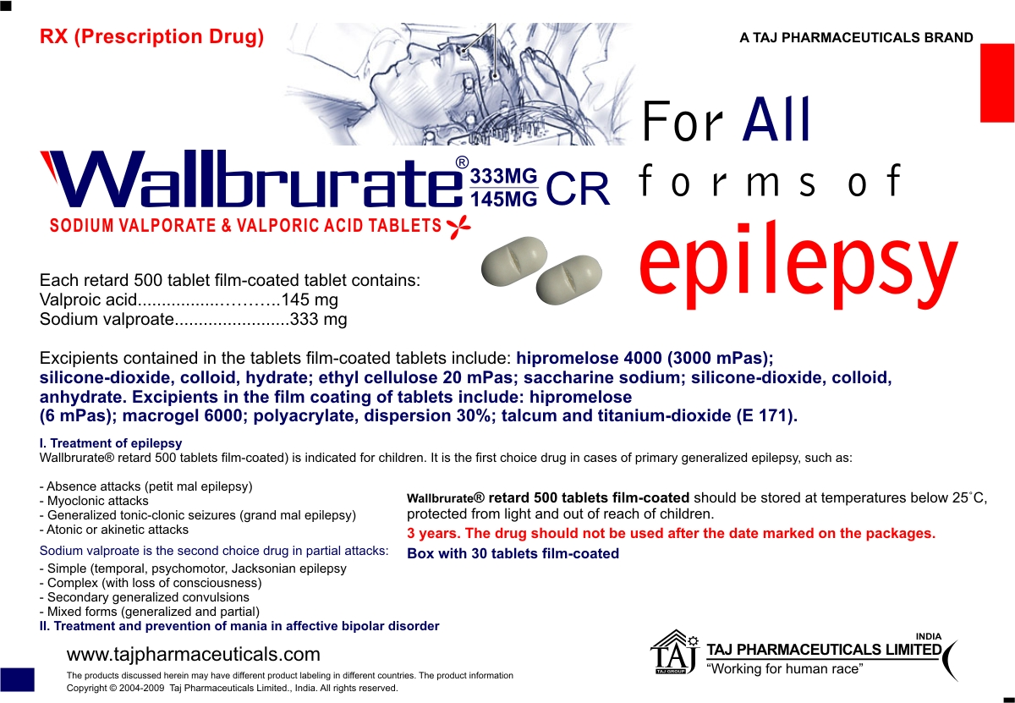
Adverse Drug Reactions
Anorexia, nausea, vomiting, drowsiness, ataxia are dose related effects Alopecia, hyperammonemia, sedation, vertigo, tremor, nystagmus and confusion can occur with prolonged use Hypersensitivity reactions like rashes and thrombocytopenia
Asymptomatic increase in serum transaminases, rarely hepatitis and pancreatitis It is teratogenic
Status in
1. Pregnancy: Contraindicated
2. Lactation : Use with caution
3. Old age : May be given in reduced dose
4. Children : May be given in dose as advised
Interactions
Phenytoin: Increases its level by inhibiting metabolism and displacing it from protein binding
Phenobarbital, primidone: Inhibits their metabolism Clonazepam: Simultaneous administration may precipitate absence syndrome Carbamazepine: Induce each other’s metabolism
Presentation
Wallbrurate Blister of 10 Tablets



