Erythrozin ®  Erythromycin …250 mg |  | Pharmaceutical Manufactures India
Taj Products
 | 
Erythrozin ®
Each tablet contains:
Composition:
Erythromycin............................................................….250 mg
Erythromycin........................................................…….500 mg
Indications:
Acute bacterial pharyngitis, tonsillitis, sinusitis, otitis, mastoiditis, epiglottitis, bronchitis, pneumonia, erysipelas, whooping cough, cellulitis, carbuncle, pyoderma, diphtheria, Legionnaire’s disease, urogenital.
Description:
Erythromycin prevents bacteriafrom growing by interfering with their protein synthesis. Erythromycin binds to the 23s rRNA molecule in the 50S of the bacterial ribosome, blocking the exit of the growing peptide chain thus inhibiting the translocation of peptides.
Side-effects
Gastrointestinal disturbances such as diarrhea, nausea, abdominal pain and vomiting are fairly common so it tends not to be prescribed as a first-line drug. However, erythromycin may be useful in treating gastroparesis due to this pro-motility effect. Intravenous erythromycin may also be used in endoscopy as an adjunct to clear gastric contents.
More serious side-effects, such as reversible deafness are rare. Allergic reactions, while uncommon, may occur, ranging from urticaria to anaphylaxis. Cholestasis, Stevens-Johnson syndrome and toxic epidermal necrolysis are some other rare side effects that may occur.
Erythromycin has been shown to increase the probability of pyloric stenosis in children whose mothers took the drug during the late stages of pregnancy or while nursing.
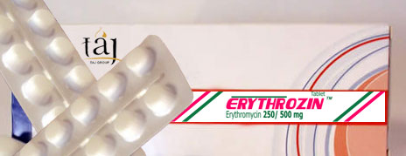

Contraindications
Earlier case reports on sudden death prompted a study on a large cohort that confirmed a link between erythromycin, ventricular tachycardia and sudden cardiac death in patients also taking drugs that prolong the metabolism of erythromycin (like verapamil or diltiazem) by interfering with CYP3A4 (Ray et al 2004). Hence, erythromycin should not be administered in patients using these drugs, or drugs that also prolong the QT time. Other examples include terfenadine (Seldane, Seldane-D), astemizole (Hismanal), cisapride (Propulsid, withdrawn in many countries for prolonging the QT time) and pimozide (Orap).
Dosage : As per the physician’s advice.
Presentations : 10 tablets

